P530/2

**BIOLOGY**

**PAPER 2**

Nov 2020

21/2 hours

**ST. MARYS’ KITENDE**

**Uganda Advanced Certificate of Education**

**RESOURCEFUL MOCK EXAMINATIONS 2020**

**BIOLOGY**

**PAPER 2**

**2 hours 30 minutes.**

**INSTRUCTIONS TO CANDIDATES:**

*Answer question one in section* ***A*** *plus three others from section* ***B****.*

*Candidates are advised to read the questions carefully, organize their answers and present them precisely and logically, illustrating with well labeled diagrams where ever necessary.*

*Write on the answer sheet , your name, stream, index number and the questions attempted in their order as shown in the table.*

|  |  |
| --- | --- |
| Question | Marks |
|  |  |
|  |  |
|  |  |
|  |  |
| Total |  |

**SECTION A (40 MARKS)**

1. Tape worms naturally secrete by hydrogen ions into the intestinal lumen of their hosts so that the carrier proteins in their cell membrane binds with more glucose molecules.

In an experiment on a dog that had been infested with tapeworms, the dog was given a glucose solution and then an acidic solution injected into its intestinal lumen.

The experiment was repeated using an alkaline solution. Figures 1(a) and

(b) shows the efficiency of absorption of glucose by the host and parasites.

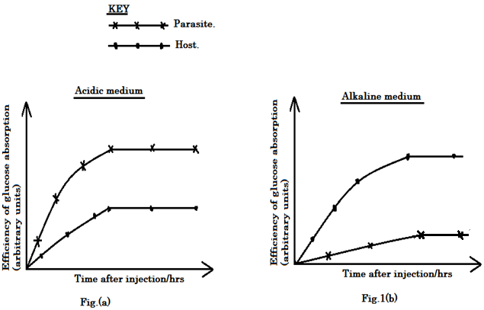

In another experiment on a dog infested by two different parasites, two drugs were separately used to eradicate the parasites.

Drug 1 was injected into the blood while drug 2 was injected into the intestinal lumen. Then the percentage of eggs of each parasite that survived after injection of the drugs was determined. Figure 2 shows the results of the investigation.

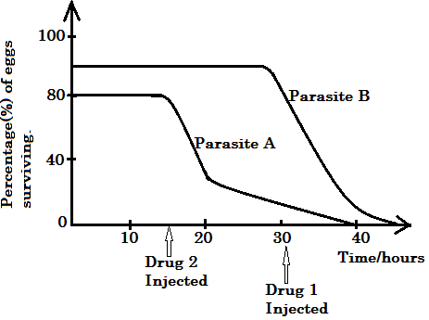

Use the above information given to answer the questions that follow.

(a)Compare the efficiency of glucose absorption by the parasites and host in,

1. Acidic medium. (03 marks)
2. Alkaline medium. (03 marks)

(b) Explain the difference in the efficiency of glucose absorption in each medium.

1. Acidic medium. (03 marks)
2. Alkaline medium. (03 marks)

(c) Explain the trend of efficiency of glucose absorption by the parasites in acidic medium. (06 marks)

(d) From figure 2, describe the variation in the percentage of eggs surviving for each parasite.

1. Parasite A. (03 marks)
2. Parasite B. (03 marks)

(e) Explain the response of each parasite to the drugs given.

1. Parasite A. (05 marks)
2. Parasite. (05 marks)

(f) Other than absorption of the host nutrients, suggest ways the tapeworm would affectthe drug. (02 marks)

(g) What benefits does the tapeworm gain from living in the dog’s intestine lumen. (3marks)

**SECTION B (MARKS)**

**2**. (a) (i) Describe events that occur leading to sickle cell anaemia disease. (07 marks)

(ii) How may occurrence of sickle cell anaemia lead to evolution. (04 marks)

(b) Explain how double fertilization is,

1. Achieved in flowering plants. (05 marks)
2. Prevented in humans. (04 marks)

**3.**(a) State characteristic features common to all counter current systems.

(04 marks)

(b) How is the mammalian kidney,

1. Adapted to carry out efficiently functions related to counter current system in mammals. (06 marks)
2. Regulate pH in mammalian blood at a set point. (10 marks)

**4**. (a) Compare each of the following,

1. Acetylcholine and noradrenaline. (07 marks)
2. CAM plants and C4 plants. (06 marks)

(b) Explain how transmission of nerve impulse is inhibited across a chemical synapse. (07 marks)

**5.**(a) Describe the trend of succession that occurs on a previously burnt and abandonedpiece of land.(08 marks)

(b) Explain appropriate conservation methods for each of the following naturalresources,

1. Wild life. (05 marks)
2. Endangered species. (07 marks)

**6.** (a) Differentiate between polysaccharides and polypeptides. (05 marks)

(b) Describe functions for various polysaccharides. (09 marks)

(c) Explain features of polysaccharides that make them ideal organic chemicalcompounds for storage.(06 marks)

**END**